Create FA Register - Workflow Functional Document

Application: | NGERP-CENTRA
WorkFlow: | FAM (Fixed Asset Management)
WorkFlow Item Name: | Create FA Register Directly

Description :

Fixed Asset Management (FAM) in an ERP system focusing on managing an organization's fixed assets throughout their lifecycle. The Key functions of FAM are Asset tracking & valuation, Depreciation Management and Disposal which includes Sales and Writeoff’ s.

Workflow Process Diagram :

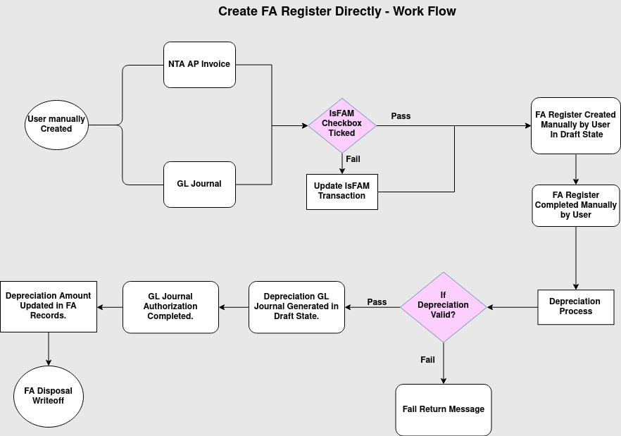

Business Rules :

- User manually created NTA AP Invoice or GL Journal with FAM check Box True.
- NTA AP Invoice allowed to FAM with only NTA product not Charge.
- If FAM checkbox is not true then use update IsFAM Transaction Form move to FAM.
- NTA AP Invoice and GL Journal Records should be completed state.
- Create FA Register record using the NTA AP Invoice or GL Journal manually.
- The following field are mandatory while creating FA Register Records: Asset Tag No, Business Line, Service Date, Department Name and IsVAS or ISGAAP.
- After created and saved, Manually completing the FA Register Transaction We must have Useful Life Span of Asset for Depreciation calculate.
- Once FA Register record completed, Based on that Depreciation process should be run manually for respective year and month.
- If Depreciation Process receives response as “Process Completed Successfully”, then Depreciation GL Journal records created automatically by system in “Drafted” state.
- GL Journal Authorization used to complete the Journal records by user manually.
- Once GL Journal record gets completed, then depreciation per month field and depreciation amount has been updated automatically in FA Register Records.
- When FA register’s Useful life in month of asset is closed up then User can manually create FA Disposal Write off and complete it.
- It may possibilities to create FA Disposal Write Off before closing of useful life month depending on Asset ‘s damage or loss.

